**Imbalanced data:**

If we have data set n, consists n1 and n2 classes  
n1>>n2 or n2>>>n1 then we call it imbalanced data set.  
we have different techniques to solve imbalanced data set issues  
1) Up sampling or down sampling  
 here we make n1 = n2 which is P(Y=1) = P(Y=0) = 1/2

2) P(Y=1) = P(Y=0) = 1  
3) modified NB to account for class imbalance(not recommended)  
Minority class is impacted on Laplace smoothing. For example:  
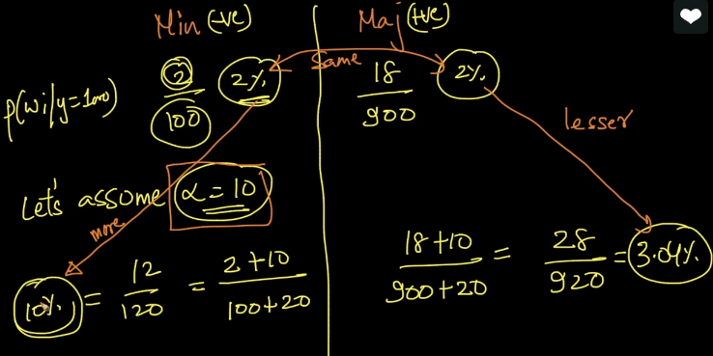  
here if you see, 2% got changed to 10% after applying Laplace smoothing.  
Instead of Up Sampling or down sampling what we can do is, we can give different alpha values for two class lables